

**SMART VACCINATION REMINDER SYSTEM FOR CHILDREN USING CROSS STACK DEVELOPMENT**

**A PROJECT REPORT**

***Submitted by***

**SANJAY S T (1919106085)**

**SNEHA S (1919106097)**

**VIJAYA LAKSHMI S (1919106113)**

**YAKESH G (1919106116)**

***in partial fulfillment for the award of the degree***

***of***

**BACHELOR OF TECHNOLOGY**

**IN**

INFORMATION TECHNOLOGY

**SONA COLLEGE OF TECHNOLOGY, SALEM-5**

**(Autonomous)**

**ANNA UNIVERSITY: CHENNAI 600 025**

May 2023

**ANNA UNIVERSITY: CHENNAI 600 025**

**BONAFIDE CERTIFICATE**

Certified that this project report “**SMART VACCINATION REMINDER SYSTEM FOR CHILDREN USING CROSS STACK DEVELOPMENT”** is the bonafide work of **“SANJAY S T (1919106085), SNEHA S (1919106097), VIJAYA LAKSHMI S (1919106113), YAKESH G (1919106116)”** who carried out the project work under my supervision.

**SIGNATURE**

**SIGNATURE**

Dr. J. Akilandeswari

Dr.P.Iyyanar

**HEAD OF THE DEPARTMENT**

**SUPERVISOR**

Professor

Associate Professor

Department Of Information Technology

Department Of Information Technology

Sona College of Technology

Sona College of Technology

Salem- 636 005.

Salem- 636 005.

Submitted for Project viva voce examination held on 12.05.2023

|  |  |
| --- | --- |
| **INTERNAL EXAMINER** | **EXTERNAL EXAMINER** |

**ACKNOWLEDGEMENT**

First and foremost, we thank to **power of almighty** for showing us inner peace and for all blessings .Special gratitude to our parents, for showing their support and love always.

We express our sincere thanks to chairman **Sri.C.VALLIAPPA** and principal **Dr.S.R.R.SENTHILKUMAR** for providing adequate facilities to complete the project.

We are immensely grateful to our Head of Information Technology Department, **Dr.J.AKILANDESWARI** forthe continue encouragement to complete theproject.

We express our heartfelt thanks to our project supervisor **Dr.P.IYYANAR** for his valuable guidance and fruitful discussions throughoutthe course of the project work.

We feel proud in sharing this success with all our department Faculty, Staff members and friends who helped directly and indirectly to completing this project successfully.

**ABSTRACT**

The Smart Vaccination System provides an SMS-based vaccine reminder framework for kids (SMS). This method is used to get the word out to guardians about the need of keeping their children up to date on their vaccinations. Vaccination appointments are now organised according to a written schedule. Yet, this approach wouldn't be sufficient since, during their hectic lives, parents can fail to remember. A web - based system that sends out reminders when it's time for a kid to get another injection is called a vaccine reminder web application, and it's designed to make parents' lives easier. By keeping parents more organised, knowledgeable, and proactive about their child's health, vaccine reminder web apps may lessen the likelihood of missed vaccinations and increase the likelihood that their children will be protected from avoidable illnesses.

**Keywords**: Vaccination, SMS, Remainder System, Nodejs express, MySQL

**TABLE OF CONTENTS**

|  |  |  |  |
| --- | --- | --- | --- |
| **CHAPTER NO.** | **TITLE** |  | **PAGE NO.** |
|  |  |  |  |
|  | **ABSTRACT iv** | |  |
|  | **LIST OF FIGURES vii**  **LIST OF TABLES vii**  **LIST OF ABBRIVATIONS viii** | |  |
| **1.** | **INTRODUCTION 1** | |  |
|  |  | 1.1 About the vaccination 1  1.2 Types of vaccines 2  1.3 Reason for vaccination 5  1.4 Objective 6  1.5 Scope of the system 7 |  |
|  |  |  |  |
| **2.** | **HARDWARE AND SOFTWARE REQUIREMENTS 9** | |  |
|  |  | 2.1 Hardware requirements 9  2.2 Software requirements 9  2.3 Database overview 9 |  |
| **3.** | **LITERATURE SURVEY 10** | |  |
|  |  | 3.1 Children Vaccination Reminder 10  Via SMS Alert.  3.2 Impact on child vaccination 11  completion rates of short message  services (SMS) reminders in  developing countries.  3.3 Development of automated text 13  message system to improve uptake of  children vaccination in Ethiopia.  3.4 Parental reminder and planner for 14  children vaccination.  3.5 Effect of Mobile Phone Text 15  Messages Reminders on Uptake of  Routine Immunization among Children  in Pakistan-Study Protocol for a  Randomized Clinical Trial.  3.6 IAP immunize india: SMS text 17  based vaccination reminder service  program-an innovation.  3.7 Childhood immunization 17  appointment reminders and recalls :  strengths, weaknesses , and opportunities  to increase vaccine coverage.  3.8 Effectiveness of short message 20  service reminder scheme in Greater  Hyderabad Municipal Corporation  for children's vaccination: A telephonic  survey. |  |
|  |  |  |  |
| **4.** | **PROJECT DESCRIPTION 23** | |  |
|  | 4.1 proposed Methodology 23  4.2 Need for proposed system 24  4.3 Implementation of proposed system 24 | |  |
|  |  |  |  |
| **5.** | **EXISTING SYSTEM** | | **26** |
| **6.** | **UML DIAGRAMS** | | **27** |
| **7.** | **RESULT ANALYSIS** | | **30** |
| **8.** | **CONCLUSION** | | **35** |
|  | **REFERENCES** | | **36** |

**LIST OF FIGURES**

|  |  |  |  |
| --- | --- | --- | --- |
| **CHAPTER NO** |  |  | **Page No** |
| **CHAPTER 3**  Fig 3.1 Architecture Diagram |  |  | 11 |
| Fig 3.2 Developing process |  |  | 15 |
| **CHAPTER 4**  Fig 4.3 Architecture Diagram  Fig 4.4 FlowChart Diagram |  |  | 24  25 |  |
|  |  |  |  |
| **CHAPTER 6** |  |  |  |
| Fig 6.1 Flow Chart Diagram |  |  | 27 |
| Fig 6.2 Block Diagram |  |  | 27 |
| Fig 6.3 Architecture Diagram |  |  | 28 |
| Fig 6.4 Component Diagram |  |  | 28 |
| Fig 6.5 Dataflow level 0 Diagram |  |  | 29 |
| Fig 6.5.1 Dataflow level 1 Diagram |  |  | 29 |
| **CHAPTER 7** |  |  |  |
| Fig 7.1 Screenshot (Login page) |  |  | 30 |
| Fig 7.2 Screenshot (Registration page) |  |  | 30 |
| Fig 7.3 Screenshot (Vaccination Scheduling Setup) |  |  | 31 |
| Fig 7.4.1 Screenshot (UserDetails) |  |  | 32 |
| Fig 7.4.2 Screenshot (Vaccination Details) |  |  | 32 |

Fig 7.5 Screenshot (Statistical report for the children vaccination) 33

Fig 7.6 Screenshot (SMS-A received message on mobile) 34

**LIST OF TABLES**

|  |  |
| --- | --- |
| **CHAPTER 1** |  |
| Table 1.2 Vaccination Schedule For Children | 5 |
|  |  |

**LIST OF ABBREVIATIONS**

**AUP** -Agile Unified Process

**BCG** -Bacille Calmette-Guérin

**CDC** - Centers for Disease Control and Prevention

**CRS** - Congenital Rubella Syndrome

**CSS** - Cascading Style Sheets

**DPT** - Diphtheria -Tetanus-Pertussis Vaccine

**DTaP** - Diphtheria, Tetanus, and Acellular Pertussis Vaccine

**FIPV** - Fractional dose Inactivated Polio Vaccine

**HBV** - Hepatitis B Virus

**Hib** - Haemophilus influenzae serotype b

**HPV** - Human Papillomavirus Vaccine

**HTML** - Hypertext Markup Language

**JEV** - Japanese Encephalitis Virus

**MMR** - Measles - Mumps- Rubella Vaccine

**MySQL** - My Structured Query Language

**OPV** - Oral Polio Vaccine

**PCV** - Pneumococcal Conjugate Vaccines

**SMS** - Short Message Service

**TB** - Tuberculosis

**TDV** - Tetanus and Diphtheria Vaccine

**TTV** - Tetanus Toxoid Vaccine

**UIP** - Universal Immunization Program

**VZV** - Varicella Zoster Virus

**WHO** - World Health Organization

**CHAPTER 1**

**INTRODUCTION**

**1.1 ABOUT THE VACCINATION**

Vaccines are drugs that stop the spread of illness. Millions of lives can be saved by administering immunisations. For instance, in 1967, 2 million people died from smallpox. By 1979, the illness was no longer present. This modification was the consequence of a global vaccination programme. A drug used to boost the immune system's defenses against disease. The regular and necessary vaccinations are designed to shield your children and those around them from diseases like rubella, polio, pneumonia, measles, tetanus, whooping cough and tetanus. Meningitis and numerous other grave illnesses. Children may be more at risk from these illnesses. Most vaccines are given by needle injection, but some can also be taken by mouth or sprayed into the nose. Immunity to a disease is provided by vaccinations without the need for prior illness. They are created using the disease-causing germ's parts or weakened, killed versions of the germ (called antigens). The antigens used in some vaccines are created using genetic engineering.

Vaccines save life. Vaccines provide security. protection for kids from any ailments that can be avoided. And if you or your children have received vaccinations, you are a link in the chain that ensures the safety of all people.In order to keep you informed on your children's immunisation schedule and to better understand the diseases they are protecting them from, we are presenting to you a series of infographics that describe the Universal Immunisation Programme (UIP). Make careful to keep the schedule and vaccinate kids for any diseases that can be prevented by vaccines.

The prevention of infectious diseases and the preservation of public health depend heavily on vaccination. The development of child-safe and child-friendly vaccines has advanced significantly in recent years, which has resulted in a decline in the prevalence of many children illnesses. Immunisations not only shield the individual child, but they also aid in halting the spread of disease across everyone. Typically, vaccinations are administered to children when their immune systems are still developing and more vulnerable to infection. Depending on their age, health, and other circumstances, children may not receive the same immunisations that are advised for adults. Vaccines against measles, mumps, rubella, chickenpox, polio, hepatitis A and B, and human papillomavirus (HPV) are frequently administered to youngsters. Medical professionals

and regulatory organisations have conducted substantial research and surveillance on the safety and effectiveness of vaccines for children. The advantages of vaccination considerably exceed the risks, despite the possibility of a few minor side effects like discomfort or redness at the injection site or a low-grade fever. To make sure their child obtains the right vaccinations at the right times, parents should speak with their healthcare professional. Parents may help prevent their kids from serious, sometimes fatal diseases by vaccinating them, as well as improve the general health and wellbeing of their community.

To increase vaccination rates against smallpox and curb the epidemic, India passed the Compulsory Vaccination Act in 1892. Except during epidemics, the "Act" largely remained in paper form. According to records, the law was in effect in about 80% of British India's districts in 1938. The below table shows the vaccination schedule for the children. Nowadays vaccination for children is the important requirement.” There is a quote called prevention is better than cure”. By taking vaccines before the attack of the disease is a good step to prevent from many diseases. Due to several work pressure the parents may forgot about their child’s vaccination.

Short message service (SMS) is an important and useful service included in mobile phones. It is offered in all types of mobile phones as it is easy to use and can operate with minimal cost . SMS permits users to communicate non-verbally, saying themselves through coalitions of alphanumerical symbols with a largest of 160 characters per single SMS message. SMS has entered global links because SMS is an inexpensive, fast and efficient means of connection between people of any distance .

To overcome this issue, we proposed a solution. Nowadays everyone is having a mobile phone along with an internet so it will be easy for the parents to register their child details in the web application and the web application remains them two days before the vaccination. The remainder sends to the parents by SMS. In our web-based system, we use NodeJS and MySQL. Nodejs is used for server-side programming particularly to run a web-based application. MySQL is used to store the data in the database.

* 1. **TYPES OF VACCINES**
* **BCG Vaccine** **:** A prominent cause of illness and mortality in humans, particularly in underdeveloped nations, is tuberculosis (TB). Since it has been around for 80 years and is included in the Universal Immunisation Programme (UIP) in many nations, including India, the bacille Calmette-Guérin (BCG) vaccine is one of the most often used immunisations available today. Children who receive the BCG vaccine are shown to be protected against meningitis and generalised TB.
* **Hepatitis B Vaccine : The hepatitis B virus (HBV) causes hepatitis B, a potentially fatal liver illness. It can lead to persistent infection and greatly increases the risk of cirrhosis and liver cancer-related mortality. In order to complete the vaccination series, WHO advises that all babies receive the hepatitis B vaccine two or three times, each at least four weeks apart, starting as soon as possible after delivery and ideally within 24 hours. Protection is likely lifetime and lasts at least 20 years.**
* **Oral Polio Vaccine : The enterovirus (picornavirus) family of viruses, which includes the three closely related poliovirus types P1, P2, and P3, is what causes the paralysing condition known as poliomyelitis. To help in polio prevention, the oral polio vaccine (OPV) is administered.**
* **Pentavalent Vaccine : A child is protected by the pentavalent vaccine from the five serious illnesses Diphtheria, Pertussis, Tetanus, Hepatitis B, and Hib. Giving a youngster the pentavalent vaccine lowers the number of pricks they receive while also protecting them from all five diseases .**
* **Rotavirus Vaccine : The most frequent cause of severe sickness from diarrhoea in newborns and young children around the world is rotaviruses. Rotaviruses, which are mostly spread by the faecal-oral route, typically infect children before the age of three around the world and before the first birthday in the majority of developing nations. Rotavirus infections, the most common cause of severe diarrhoea in young children, are prevented with the rotavirus vaccine. (Reference: WHO)**
* **FIPV Vaccine** : Immunisation can protect against polio. Multiple doses of the polio vaccination almost always provide a youngster with lifetime protection. One of the most significant medical advances of the 20th century was the creation of paralytic polio vaccinations.
* **Measles Rubella Vaccine :** The severe viral infection known as the measles is spread by respiratory secretions. Fever, rash, cough, and conjunctivitis are among the symptoms. Children under 2 years old and adults have the highest rates of complications and fatality. Children and young adults are most frequently affected by the infectious, mostly mild viral infection known as rubella. Congenital rubella syndrome (CRS) is a term used to describe congenital abnormalities brought on by rubella infection in pregnant women. Rubella does not have a specific therapy, however it is curable with immunisation. CRS during pregnancy has been linked to significant birth abnormalities, stillbirths, and spontaneous abortion.
* **DPT vaccine :** The DPT vaccine, sometimes known as the DTP vaccination, belongs to a group of combination vaccines that protects against diphtheria, pertussis (whooping cough), and tetanus in humans. Diphtheria and tetanus toxoids, as well as pertussis antigens or dead pertussis-causing bacteria cells, are included in the vaccination. The primary dose of DPT included in the pentavalent vaccination and two booster doses are administered, respectively, at 16 to 24 months and 5 to 6 years.
* **Td Vaccine :** Tetanus and diphtheria are combined in the Td vaccine, which contains less diphtheria antigen (d). All age groups in the nation, including expectant mothers, should switch from the TT vaccine to the Td vaccine, according to the Ministry of Health and Family Welfare.
* **PCV Vaccine :** Around the world, pneumococcal infections are a common source of morbidity and mortality, with young children and the elderly being particularly vulnerable.Pneumococcal conjugate vaccines (PCV) are a part of paediatric vaccination regimes, especially in nations with high rates of infant mortality**.**
* **JE Vaccine :** Pneumococcal infections are a frequent cause of morbidity and mortality throughout the world, particularly in young children and the elderly. Paediatric immunisation programmes often include pneumococcal conjugate vaccines (PCV), particularly in countries with high newborn mortality rates.

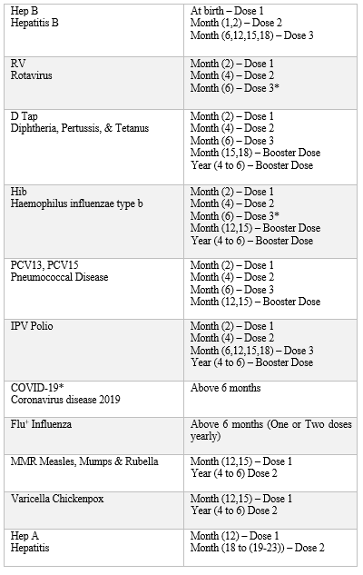

**Table-1.2** **Vaccination Schedule For Children.**

* 1. **REASON FOR VACCINATION**

**Immunizations can save your child's life : More diseases than ever before can be prevented for your child thanks to advancements in medical research. Many diseases that previously sickened or killed thousands of children have been totally eradicated, and others are on the verge of extinction thanks in large part to reliable immunisations. One illustration of the significant impact immunisations have had in the US is the eradication of polio. Thanks to immunisation, polio has been eradicated in the United States, where it was once the most feared disease and the cause of death and disability.**

**Vaccination is very safe and effective : Only after a thorough and extended evaluation by scientists, physicians, and other healthcare professionals are vaccines administered to children. In contrast to the pain, discomfort, and trauma of the diseases these vaccines are intended to prevent, the discomfort associated with vaccinations—which may include pain, redness, or tenderness at the injection site—is minor. Serious adverse reactions to vaccinations, like life-threatening allergic reactions, are extremely uncommon. For almost all children, the advantages of receiving vaccinations in terms of disease prevention outweigh the potential risks.**

**Immunization protects others you care about : Vaccine-preventable illnesses still affect children in the United States. In fact, over the past few years, measles and whooping cough (pertussis) have both made a comeback. Between 10,000 and 50,000 whooping cough cases have been reported in the US annually since 2010. Each year, 10 to 20 infant deaths occur, many of whom were too young to receive all of their vaccinations. While some infants are too young to receive immunisations to protect them, others may not be able to due to severe allergies, compromised immune systems from diseases like leukaemia, or other factors. It's crucial that you and your children who are able to receive vaccinations are properly immunised to help keep them safe. It also assists in protecting your family.**

**Immunizations can save your family time and money : A child who has a sickness that is preventable by vaccination may not be allowed to attend nursery or school. Some**

**diseases that can be prevented by vaccination might cause long-term disabilities and cost a lot of money because of lost wages at work, hospital expenses, or long-term disability care. Contrarily, getting protected from these diseases by vaccination is a wise expenditure that is typically covered by insurance. A nationally financed programme called "Vaccines for Children" offers free vaccinations to kids from low-income families.**

### OBJECTIVE

The core of this project is to help the users to get their vaccination shot at the right time. Our aim is to develop a smart vaccination reminder system using NodeJS express and MySQL. And we use SMS gateway for sending the messages to the user. SMS contains the date for the next vaccination shot along with the dose number and vaccine name.

**Increase vaccination coverage and timely vaccination of children:** The system aims to provide timely reminders to parents/caregivers about their child's upcoming vaccinations, reducing the likelihood of missed vaccinations or delayed vaccinations, and increasing the overall vaccination coverage.

**Improve communication between healthcare providers and parents/caregivers:** The system can facilitate better communication between healthcare providers and parents/caregivers, ensuring that parents/caregivers are informed about their child's vaccination schedule and any changes to it.

**Reduce administrative burden on healthcare providers:** The system can automate the process of sending vaccination reminders, reducing the administrative burden on healthcare providers and freeing up their time for other tasks.

**Enhance data collection and analysis:** The system can collect and analyze data on vaccination coverage, missed vaccinations, and other factors that may affect vaccination rates. This information can help healthcare providers to identify areas for improvement and to develop targeted interventions to increase vaccination coverage.

**Improve overall health outcomes:** By increasing vaccination coverage and reducing the risk of vaccine-preventable diseases, the system can contribute to improved overall health outcomes for children.

**Provide a user-friendly and accessible platform:** The system aims to provide a user-friendly and accessible platform for parents/caregivers to access information about their child's vaccination schedule, making it easier for them to stay on track with their child's vaccinations.

* 1. **SCOPE OF THE SYSTEM**

A proper vaccination schedule should be followed to keep a child healthy and protected from potential deadly disease risks in the future. However, a lot of parents either are unaware of the schedule or forget about it, which makes their child more susceptible to illnesses. A system should be put in place to send parents a mobile SMS prior to the vaccination schedule to prevent child deaths solely due to this cause. Depending on the specifics of the child, the system would

need to be built to handle various vaccination schedules. Prior to each scheduled vaccination, the system would be set up to send parents or guardians SMS reminders at the appropriate intervals. To ensure that the messages are effective in encouraging parents or guardians to bring their child for vaccination without becoming overwhelming or obnoxious, the frequency and timing of the messages must be carefully considered. The system would need to be created to guarantee that private and secure personal health information about kids and their families is maintained, and that the necessary safeguards are in place to prevent unauthorized access or use.

**CHAPTER 2**

**HARDWARE AND SOFTWARE REQUIREMENTS**

* 1. **HARDWARE REQUIREMENTS**
     + Processor: i3
     + Hard disk: 1 GB
     + Ram: 2 GB

**2.2 SOFTWARE REQUIREMENTS**

* + - Back-End: NodeJS Express 18.14.0
    - Front-End: HTML 5.0, CSS 3.0, Javascript

**2.3 DATABASE OVERVIEW**

* + - * Engine: MySQL
      * Database: vaccine_db
      * Database Schema: Database SQL

**CHAPTER 3**

**LITERATURE SURVEY**

**3.1 Yuhanis & Asam (2018)**  [14] In this paper, first, the parents must register the children’s details at a partner health care or clinic. In the clinic, the staff members or admin will register the details of the children (name, surname, phone number, email, password). The children's and parents' details will be saved after registration. Then, two days before the SMS will be sent based on a default option before the scheduled vaccine, a reminder will be sent to the registered mobile number [15]. Information about the child's name, the vaccine type to be administered, and the appointment date would be included in the SMS message that was received. In this paper for the server-side SQL environment they use (Ado.net) and Visual code. The children vaccination reminder system via SMS alert operates. First, parents who decided to use the system will register in any participating health center (or clinic). Registration will be done by the workers of the participating health centers or clinics. During the registration, information on the parents and child will be stored. This includes data on parents mobile number and date of birth of the registered child (Figure 3.1). A reminder will then be sent to the registered mobile number two (2) days (this is based on a default setting) before a vaccination is scheduled for. The SMS received would contain information on the child’s name, type of vaccine to be taken and the date of the scheduled appointment .There are two techniques that are used in Visual Basic.Net (Ado.net). The two techniques are most useful for programmers. These techniques are mostly used on the Ado Net. Entity Framework and query integrated language. The first technique provides the ability to object to orient data bases directly and write queries within the code Visual Basic. The second technique provides model objects which are powerful and new and has new features and tools to make the databases free [10]. The administrator of the respective hospital will be able to see the message status whether it is (received, not received). The administrator will send the message again if it is not received. It is useful for parents because there is a chance of forgetting about the schedule at that time. This system will automatically alert the parents about the schedule. The users need to log-in. Only authorized users (people working in the health center/ clinic) are able to use the system and this is due to security purposes. A user needs to provide a user name and password. If both of the information are correct, then the system will display the

main page, else if is incorrect the system will display an error message (“The UserName or Password you entered is invalid . Click ok to re-enter”). The main page for Children Vaccination Reminder System Via SMS Alert. This main page consists of two components (Child Info and New user). The send message page for Children Vaccination Reminder System Via SMS Alert will be displayed when user clicks on the Child Info button. Registration of new users (i.e parents) can be made by clicking the New User button.

In the Child Info page, a user can add new child or change information on existing child. When a reminder has been send to a user, the system will display a message (“OK 000, message has been sent,[1] ID: 205735”) . This message is from the service provider. In addition, the system will display on ‘list box’ some info about the child, to whose parents the message was sent, such as name, age, hand phone, and type of vaccine. The alert message will be sent to parents’ mobile phone from the system two days before the vaccination date, and it contains name of the child, type of vaccine, date and name of the health center.

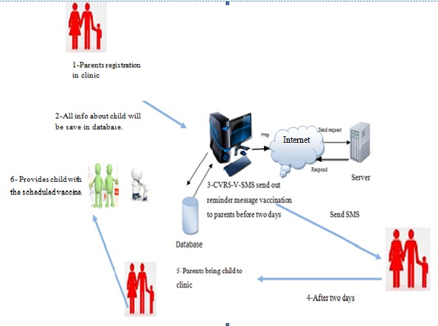

**Figure 3.1 Architecture Diagram**

1

.

Parents registration in clinic

. Provide

6

child with

the

schedule

vaccine

. Info on child

2

will be saved in

database

4

. After two days

5

. Parents

bring child

to clinic

3

. System send vaccination

reminder msg to parents 2

da

y

s before a

pp

ointment

**3.2 Robert et al. (2020)** [2][8] The studies had created a positive view for SMS warning system in immunization inclusion. Introducing this extent is main as more countries make one’s home as 2YL (2nd old age of growth) approach, this approach has more urgent necessities for

first two age of growth. Without proper enhanced mcv2 coverage, many underdeveloped countries need measles campaigns for every 2 or 3 years. It will be helpful for donors and governments of

the country for accompanying profitable in SMS projects. If the country has weak completion rates means, then it should be needed to grant permission for SMS projects [12].SMS creates a gateway for many immunization reminders. There is a review on Cochrane it states about the dial calls, document ideas, and ideas for autodial in the reminder system. e.g., There are many effective postal methods is in exercise. Using the same procedures as those employed in the 2017 article on SMS reminders, of which this is an update, I searched the NLM database for all recent articles from developing countries on SMS reminders for reduction of vaccination dropout rates. I summarized these and earlier articles in tabular form. Some are exhaustive for labour, as in fact health traders in underdeveloped countries are frequently lacking time. When the best plan includes beginning enrolment, SMS warnings are best for potential work and creates opportunity for inventors or caregivers having access to telephones. In Burkina Faso, SMS accompanies as an electronic additional dose for vaccine registers and act as the best reminder for vaccination which is said by their health administration. Those registers bring business related benefits on funds. Voice message is also a good alternative method for sending reminders. Though it also needs a constant signal.

The studies reviewed showed a positive impact on routine vaccination coverage of SMS reminder systems. All were of pilot projects. Further work in this area is important as more countries move to a 2YL (second year of life) approach, with more demanding requirements for sustained high coverage over the first two years of life. Without improved MCV2 coverage, most developing countries (Rwanda is a remarkable exception) will continue to need measles campaigns every two or three years, with all which this implies in terms of demands on human resources at the national and subnational levels. It would be useful for governments and donors in countries with successful SMS projects to go to scale. Countries which have not yet launched SMS projects may wish to do so, especially if they have poor completion rates. SMS reminders are but one of several approaches to vaccination reminders. The most recent Cochrane review, cited above, lists telephone calls, letters, postcards, text messages, and autodial messages as among reminder/recall methods. However, many of these rely, for example, on efficient postal systems for implementation. Some are labour intensive, whereas health workers in developing countries are often short of time. When part of a larger system including birth registration, SMS reminders have the potential to work without heavy time inputs and wherever mothers or other caregivers have access to mobile telephones. Combining SMS reminders with an electronic immunization register, as in Burkina Faso, places the SMS reminder in a larger, comprehensive health management information system. Such registers, in addition, present economic advantages in terms of savings on printing. Voice reminders, only feasible in places with stable network signals, are an alternative to SMS messaging.

**3.3 Kassahun et al. (2019)** [3][11] Existing practice on the immunization schedule is by way of written appointment. Nevertheless, a specific approach to granting permission will not be sufficient as people consider the possibility to ignore it due to a closed work schedule and day-to-day routines. Missed assignments are too, a preventable, which impact upon the energy effects of customers. Similarly, poor knowledge about additional doses of vaccine schedules and inattention were the most quoted reasons persons present for not completing their infant’s additional dose of vaccine quickly.

As the use of facts and ideas sciences (ICT) has become the central nervous system of all new frugalities, making health organizations brisker is consistently achieved through the use of ICT exhaustive answers like mHealth. Among the mHealth interferences, SMS is one that bears a short message service, a telecommunications code adopted as an analogue for ideas.

Mobile SMS has become more common because it is smooth and simple to use, and each type of cellular telephone has this different application. Health laborers are further increasingly taking advantage of SMS-located keepsake systems to develop ward rude answers and continuity of care. Hence, plain and direct SMS located mHealth interventions that may be dosed in the existing health orders are necessary to increase caregiver’s attendance for up-to-the-minute additional doses of vaccine in Ethiopia.

The SMS-based whole warning influence varies across various scenes. In line with this, a randomized reserved trial (RCT) study is being conducted to test the influence of these communication reminders in reconstructing the progression of immunization services in North-West Ethiopia. This trial is necessary to produce evidence on the influence of text communication notices on the rude answer of routine child cover additional dose of vaccine that will then be scaled up into analogous terrestrial regions in the country. Therefore, this text idea located in the mHealth mediation package has been grown as an interference package for the RCT study.

This paper is manifested by virtue of what is best to cultivate an automated keepsake plan for the immunization program in the Ethiopian context. The study marked the significance of gets feedback about the content of these ideas and iteratively experimented the developed whole before real deployment. Research verdicts too disclosed that tailoring the warning for whole established client choices and asking for diversified modalities results in better incidents. More evidence shows that content ideas should combine patterns of guaranteeing that the text ideas are grown and proven in the most appropriate habit before they are redistributed.

Strengths and restraints: The developed warning plan is guaranteed with a shielded identification user interface that gives shields to bureaucracy. The system works offline by producing publications with computer software request and can be achieved by chance accompanying network connectivity. The use has auxiliary arrangement. The system is easy to revise on various domains. As a challenge, weak network connectedness and bugs inside the system overwhelmed the shipping process of the text messages during testing of the system. This led to recurring experiments of the mechanized system with it favourably with all the desired ideas. Since the automated system is modem based, it only confirms the automatically dispatched text messages sent status from the system. However, it managed not confirm the real transmittal of the textbook messages to the movable phones of each person caring for the child.

**3.4 Siti et al. (2019)** [4][14] The Reminder for child’s vaccination is done by methodology of agile. Unified process of agile is applied for the development phase. The Parental Reminder and Planner for Children Vaccination is developed by using agile methodology, Agile Unified Process (AUP) is used for the development of this system. This methodology is easy to be understood as it has a simple descriptions and straight to the point which is easy to be applied especially in developing a system or software. Firstly, in the inception phase research is done through the internet, journals and also try-out of few systems similar to the system that will be built to get the clear vision of how the system should work and also to the experiences from different types of system which offer different features. Secondly, in the elaboration phase the data analyzing will be conducted in this phase which the result of all the data gathering methods will be analyzed and also the coding, mechanism and approach that will be used to create the system will be determined. Meanwhile, in the construction phase the remaining requirements of the projects were identified and the sketched design of the system done (Figure 3.2) by using Microsoft Visual Studio 2010 to develop the project. In the transition phase, this systems testing is focused and the validation of the complete system is done in this phase. The type of research method which is used are survey and observation. The survey is done by using survey papers and it was distributed to the Faculty of health and life Sciences students. The total number of questions are 10 questions, the question were about the features and the performance which are in the Kids Vaccination Planner together with the usability of the web-based system, lastly whether it’s convenient to use or not was questioned

as well to the users.Meanwhile, the observation is been done near the area of Section 7, Shah Alam. The reason for selecting this place is because it is the nearest place that can be found to do observation about the vaccines that are needed by kids.

**Figure 3.2: Developing process**

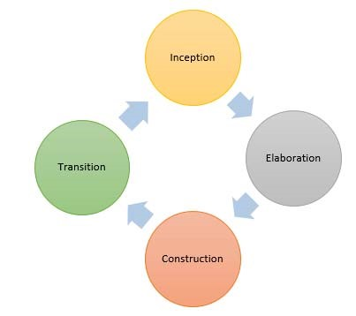

There is table for our reference regarding the vaccines that the kids need according to their age . The software that is used to develop the Kids Vaccination Planner is by using Visual Studio 2010, Google Cloud and www.SMS123.Net. The purpose of using Visual Studio to create this web-based system in Asp.net programming language which is available in Visual Studio. Besides that,

the Google Cloud is used to store the database of this web-based system and to implements the database of this web-based system. Other than that, the SMS gateway which is used to generate SMS to the user of this web-based system is [www.SMS123.Net](http://www.SMS123.Net). The design for the system was done in several UML diagrams which are class diagram, communication diagram, sequence diagram, activity diagram, use case design and state diagram. The sequence diagram and communication diagram must be similar to make sure that the system can run alike, where it must follow the class diagram flow. In order to that, the system interface is made to showcase the functions and the feature of what each interface has in this web-based system.

This method is good in understanding, and it has very simple descriptions, so it is not tough to apply, moreover it is applied for developing software or system. The system utilizes VS Code (2010), google cloud & the computer network, sms123.net. The main purpose for utilizing VS code is to make this network- located plan in asp.net register expression that is accessible in VS Code.

**3.5 Hussain et al. (2017)** [3][13] To determine if SMS reminders on smartphones are more helpful at ensuring that children receiving visits on 2, 4, 6 months based on the schedule. To create an inexpensive automatic SMS text messaging computer application with easily comprehensible texts based on preferred languages. It is a randomized clinical study, and our research design

consists of three parts: a baseline survey of parents and carers to learn about their preferences for SMS immunisation reminders. The scheduling of SMS reminders will be handled by a computer programme. The mobile number, text message, language changing settings, based on the date the message will be send to the user. To send the message, it will interface with the gateway. If the Mobile number is valid then the SMS will be sent successfully.

# **Methods**

## **Research hypothesis**

To prove that the RI uptake and compliance according to the schedule can be increased through SMS reminders in LMICs and to incorporate this program within the existing health systems by collecting mobile phone data of parents and caregivers of children less than 6 weeks of age.

## **Primary objectives**

To assess the effectiveness of SMS reminders on mobile phones in improving the uptake for RI in children at 6, 10 and 14 weeks of age according to the EPI schedule in Pakistan

## **Secondary objectives**

To assess the effectiveness of SMS reminders on mobile phones in improving the on-time visit for RI in children at 6, 10 and 14 weeks of age

To develop a low cost automated SMS text messaging computerized program with simple understandable messages according to language preferences

## **Study design**

It is a randomized clinical trial and our experimental plan has three components:

A baseline survey of parents/caregivers to explore preferences related to SMS reminders for immunization.

A computerized application will be developed for SMS reminders scheduling. This application will contain the phone numbers, SMS text message information, language preferences and date on which the message will be sent. It will be interfaced with the gateway to send the message.

Parents/caregivers of children randomized in the intervention arm will be sent SMS reminders of RI visits at 6, 10 and 14 weeks of life.

## **Study site**

This study will be carried out in an urban- squatter settlement area of Ibrahim Haidry (IH) union council (UC) in Karachi. This is part of Aga Khan University’s Department of Pediatrics and Child Health’s health demographic surveillance (HDSS) on maternal and child health being conducted since 2008. IH is a low- income community with total population of the active surveillance catchment area is 120,725. About 2,000 pregnant women and 1900 newborns are added to the surveillance system annually.

## **Study population**

Infants as part of the HDSS cohort conducted by the Department of Pediatrics in IH catchment area will be recruited for this study.

## **Sample size calculations**

Target recruitment would be 300 infants per site; 150 in each arm of the study. Assumptions used for calculating sample size are increase in coverage rate from 60% to 80%, power at 0.8, alpha error at 0.05 and allowing for 10% dropout.

## **Enrollment criteria**

**Inclusion criteria:**The inclusion criteria include a child being less than 14 days of age with parent/guardian or at least one person in the household having a working mobile phone connection and parent/ guardian providing consent to participate in the study.

**3.6 RK Pejaver (2020)** [5][10] A national sort code was used to develop a piece of software. Anyone can register through this number 566778 by giving the child’s name and the DOB of the child (Vaccination->Name->DOB). Every time youngster is due for a vaccination for the following 12 years, reminders will be sent to the same phone. There will be three reminders—two remainders before the week of the schedule and one is after the vaccination. This is available everywhere in India on all mobile networks. The client is not charged for it. In order to support

the initiative, Indian Academy of Pediatrics (IAP) joined together with Immunize India Charities. With more than 30,000 members, the Indian Academy of Pediatrics is a professional organization. IAP serves as a motivator and distributor. Immunize India Charities is still handling the program's administrative tasks. For kids who have finished their vaccine schedule, there is the option to join the programme. A family has the choice to reject the programme.

**3.7 K.M. Jong et al. (2021)** Reminder/recall policies and practices across Alberta were explored via an environmental scan.Alberta is a province in Canada with a single, province-wide healthcare delivery system operated by Alberta Health Services (AHS). For administration purposes, the province (population 4.1 million) is separated into five zones: North, Edmonton, Central, Calgary, and South. Within each zone, recommended childhood immunizations are

publicly funded and administered by nurses in community-based public health centres (PHCs), starting at two months of age.This study took place in all five zones, including urban and rural settings. In phase I of the study, public health directors and/or designates of each zone were contacted via email for a telephone or in-person interview. Participants were asked about zone-wide reminder/ recall policies, perceived strengths and weaknesses of current strategies, suggested improvements and any plans to update reminder/recalls. In phase II, we contacted (through intermediaries) the managers (n ¼ 43) of all 136 PHCs that provide immunization services in Alberta. Managers were asked to complete an online survey with the choice of completing surveys for each PHC they oversaw, or designating a nurse from each PHC to do so. The survey addressed current reminder/recall practices, perceived strengths and weaknesses and suggested improvements. Study data were collected and managed using REDCapelectronic data capture tools hosted and supported by the Women and Children's Health Research Institute at the University of Alberta. We used content analysis of phase I participants’ interview responses to identify major thematic categories. We conducted descriptive analysis of phase II survey responses. Data analysis occurred in 2018 and 2019. Participants reported that reminders were most commonly sent by telephone calls. These were also frequently used for recalls, with some zones supplementing with postcards or letters. Participants from three zones indicated that while text message reminder/recalls are used in a few PHCs, this was not pervasive or consistently performed, particularly for recalls. However, most zones had plans to increase use of text message reminder/recalls in the near future, as technology being introduced across the province would be capable of sending automated texts. Participants identified the adoption of newer technologies, such as text messaging, into reminder/recalls as being advantageous. Participants from two zones reported that a major advantage of texts is their ability to contact individuals that were previously difficult to reach; for instance, families with transient lifestyles and lower socio-economic status who relied on cellphones with textonly plans because of costly telephone minutes. Participants foresaw that text messaging would facilitate contact with more parents. In one zone, text message reminders were piloted at a PHC that served a largely transient population with high ‘no-show’ rates. When implemented with other reminder methods, they reported that texts were well-received/preferred by parents and ‘no-show’ rates noticeably decreased.Some participants stated that while there is progress with updating reminder/recall technologies, methods need to continue to be modernized. One participant suggested exploring social media platforms, while another proposed an online system that also facilitates appointment booking. A third participant supported email-based reminder/recalls, as this would allow PHCs to provide more extensive educational information.Of

phase II participants, 41.6% believed text message delivery could improve reminder systems. A phase I participant whose zone had piloted text messages stated that many parents preferred communication via texts. Two phase I participants stated that a significant number of parents, particularly those with transient lifestyles and lower socio-economic status, rely on cellphones with text-only plans; thus, the use of texts better allowed PHCs to reach these clients. Other studies similarly found that text message reminder/recalls were beneficial for low-income minorities.For these populations, cellphones were a more reliable form of communication than landlines or mail,as cellphone contact information was often more stable than a home address or landline phone number.Low-income minorities were more likely to only use cellphones and communicate via text messaging, as compared to non-minority individuals of higher socio-economic status.Studies have also shown that parents favoured receiving texts over mail- or telephone-based communication.Additional benefits of text message reminder/recalls include their ability to access a large proportion of the population,facilitate communication more promptly and convenientlyand provide parents with a record of information (e.g. clinic's hours, address and phone number) which could later be referred to. Phase I participants reported plans to implement automated reminder/recall systems throughout all zones. Phase I participants regarded this change positively, believing this would enhance the efficiency of reminder/recall systems, allowing staffing resources to be concentrated elsewhere, and would promote consistent reminder/recall delivery. This was also supported by phase II respondents, where a frequently reported weakness of reminders (27.4%) and recalls (17.8%) was the time-consuming, resourceintensive nature of manual systems. Many participants suggested automated reminders (25.7%) and recalls (16.8%) would improve current systems. Supported use of automated reminder/recall systems, citing benefits such as decreased costs, reductions in staff workload and more consistent reminder/recall usage. Further, that automated reminders can be individualized and are effective at promoting appointment attendance regardless of gender, age group or socioeconomic status of the target population.The limited research performed on the timing of immunization reminders suggests that parents do not have a stated preference for time of day they are received.However, it seems likely that sending messages to parents in the evenings, when they are most likely to be available, might be preferable. Having an automated system in place would allow for timing of messages to be scheduled based on the time of day they are most likely to be received. Drawbacks to automated systems were also reported. Phase I participants believed automated reminder/recalls would eliminate the personal contact facilitated by manual calls. This was echoed by 2.8% of phase II participants regarding recalls. It

was also noted that some clients have reported difficulty understanding automated reminders (1.8%) and that clients have received multiple automated calls regarding the same appointment (1.8%). These potential disadvantages should be considered, as automated systems become widespread.

**3.8 Shakeel et al. (2015)** [8][15] The telecommunication system in India is the 2nd largest in the world after China. India has the fastest growing telecom network in the world with its high population and development potential with the total wireless subscribers to reach 91.87 crore at the end of July 2014. As mobile phones have revolutionized our lives and SMS being an integral part of the mobile phones, the survey here concentrates on the usage of this facility in the public health point of view to the maximum. This study focused on the reliability of the SMS service during both normal and overload operating conditions. SMS service has many advantages. SMS messaging software allows text messages to be sent at once to a large population. SMS reminders require minimal continued investment in IT infrastructure, given that the IT software is in place for sending automated SMS and integrated with existing electronic patient health records and hospital administrative database systems. Once the system is in place, the cost of running the service increases very little as the number of SMS reminders goes up. In addition, given that the messages are automated, there is no requirement for staff training, allowing for a time, labor, and cost-efficient system. Most young people in developed countries are very familiar with the technology.

However, according to the present study the reliability of SMS service was found to be less as the delivery rate of SMS was only 21.8%. This is similar to the study done by Szilagyi *et al*., in which audiotaped telephone reminders were sent about the scheduled immunization visit. The study showed a lack of success largely owing to changed or inaccurate telephone numbers. Few subjects, 4.6% of the individuals reported that they cannot read the SMS as they were uneducated, and 7.1% individuals do not have the habit of seeing messages as they were not that familiar with the technology. Upon interviewing, these individuals had put forth the need for some other way of vaccination reminder which would benefit them. Retrospective assessment methods are subject to measurement errors since the precise recall of the details asked declines considerably due to memory deficits. In the present study, 2.6% of individuals were not sure in giving the details if they

have received the SMS from GHMC or not and also 3.1% of the individuals who received SMS from GHMC were unable to recall the details of when and how many SMS did they receive from GHMC. Irrespective of the SMS received from the GHMC, the timely vaccination rate of the children was high (74.2%). However, this should not be misinterpreted that the vaccination rate in

India is high. Interestingly it was noticed that, in spite of them not depending on the SMS for timely vaccination, the majority of subjects (71.9%) wished to get the SMS reminder from GHMC regularly. This was similar to the study was done by Bangure *et al*., in which all subjects were willing to receive the SMS reminders. In the study done by Stockwell and Fiks, it was described that the one field where text messaging so far has been successful in both pediatric and adult

populations is vaccination reminder. In a national study, 56% of the 1612 parents surveyed were willing to register their cell number with their child's usual vaccination provider, and another 18% were undecided. In the present study, 28 individuals (8%) did not wish to get any SMS from GHMC due to varied reasons such as the fear of costing them for SMS, spam SMS, depending on SMS would be problematic if there is any delay in the messages from GHMC. This was also reported in the study done by Anhøj and Møldrup that it might be difficult to find participants due to the fact that they would have to supply their private cell phone number or for fear of receiving spam SMS. Those individuals who provided a mobile phone contact number may have been more motivated patients and more likely to attend their appointment, irrespective of being sent an SMS reminder.

Reasons for not getting the children vaccinated were also studied. In the present study, 5.7% did not get their child vaccinated due to reasons such as not knowing the place where to get vaccinated due to shifting of their residence area recently, difficulty in remembering the schedule on the day of vaccination, child ill health, and family problems. Public opinion on improvements to SMS reminder format was also taken. Many of the individuals requested for the details of cost of vaccination to be provided in SMS, details of nearby hospitals with vaccination provision, Regular Government, polio vaccination reminder also to be sent through SMS. In the study done by Foley and Neill, which assessed SMS service and its effect on patient attendance reported various reasons for missing dental appointments. The reasons include, the patient/carer forgetting their appointment, confusion over the date, time and location of the appointment, illness, and transportation difficulty. The study also mentioned the use of SMS text messages as a reminder may reduce the failure to attend rate for outpatient pediatric dental appointments.

As usual along with many advantages, it also has few potential limitations. The study population is restricted to only cell phone users. Its success is strongly associated with the accuracy

and updation of the subjects telephone numbers. In countries with a low proportion of cell phone users, the presented method might be less appropriate. The particular subgroups like children or the elderly, who are less familiar with the technology and illiterate, might have problems understanding the procedure or show reactivity. Furthermore, there might be a restriction to not

exceed more than 160 characters (less for some carriers) constraining the amount of information that can be included. Based on above analysis, automated SMS reminder service looks to be a promising tool requiring minimum time, labor, and cost. Hence we suggest, regular feedbacks and self-evaluation of service should be done for maximum efficiency. Technical considerations in the SMS service should be looked into and rectified regularly. Also, SMS Reminders in local languages may benefit the natives.

**CHAPTER 4**

**PROJECT DESCRIPTION**

**4.1 PROPOSED METHODOLOGY**

Define the user requirements: The first step is to identify the target users of the system and their specific needs. In this case, the target users would be parents of young children who need to keep track of their child's vaccination schedule. The requirements could include features such as automated reminders, easy access to vaccination records, and a user-friendly interface.

Research existing systems: Before starting development, it is important to research existing systems to see what features they offer and what could be improved upon. This could involve reviewing scientific literature, interviewing healthcare professionals and parents, and examining current vaccination reminder apps.

Choose the hardware platform: Once the user requirements and existing systems have been studied, the next step is to select a hardware platform for the system. This could be a smartphone, tablet, or other device that can support the software and provide users with a convenient interface.

Develop the software: The next step is to develop the software that will run on the chosen hardware platform. This could involve building a mobile app or a web-based application. The software should be designed to be user-friendly and intuitive, with clear navigation and easy access to vaccination records.

Integrate with healthcare providers: To ensure that the vaccination records are up-to-date, the system should be integrated with healthcare providers' databases. This could involve working with healthcare providers to develop an API or other data exchange mechanism.

Test the system: Before releasing the system to the public, it should be thoroughly tested to ensure that it works as intended. This could involve beta testing with a group of parents to get feedback on the system's usability and effectiveness.

Release and promote the system: Once the system has been tested and refined, it can be released to the public. This could involve promoting the system through social media, healthcare providers, and other channels to reach as many parents as possible.

**4.2 NEED FOR PROPOSED SYSTEM**

The initial vaccination appointments are only made in writing. There are many circumstances in which parents may forget about their child's vaccination schedule. For example, if a paper is missed, thechildren's vaccination schedule may be collapsed. Another scenario is when parents are too busy with their demanding work schedules and forget about the child's schedule. The SMS reminder was developed to solve this problem by sending the message to the right person at the right time. However, some security was lacking when sending messages, so we planned to develop this vaccination system. We send the message in a secured way.

**4.3**  **IMPLEMENTATION OF PROPOSED SYSTEM**

In this web-application the admin registers the child’s information’s in the register page. Registration is must to get the message and only for the valid mobile numbers the message will be send. Next it goes to vaccination page and admin enters the user’s vaccine details. After that the admin can login with the specific application id of users which is generated to user through SMS along with their next vaccination shot. Figure 4.3 shows the pictorial representation of our vaccination reminder system. The entire proposed system is developed using Nodejs express and MySQL.The Nodejs express which is used to connect with the backend and MySQL is used to store the data information.

**Figure 4.3: Architecture Diagram for our proposed system.**

We can also view the individual profile and there is an update button where the admin enters the current vaccine information, and this method is beneficial for both doctors and childcare facilities. It is very helpful for the doctors to check the records. There is a potential factor that the signal might be lost, in such case the message won't be delivered correctly on time. The administrator of the respective hospital will be able to see the message status whether it is (received, not received). The administrator will send the message again if it is not received. It is useful for the users because, there is chance to forget about the schedule at that time and this

system will automatically alert the users about the schedule. The below diagram represents the flow of process Figure 4.4 shows the diagrammatic representation of our vaccination reminder system.

**Figure 4.4: Flow Chart Diagram for Vaccination Reminder via SMS.**

**CHAPTER 5**

**5.1 EXISTING SYSTEM**

In the existing system, the administrator created a web-based application. In that web-based application the admin created registration page where the user was required to enter information that would be stored in the database. Some of them used Google Cloud to store the information, making it easy to retrieve and eliminating the risk of data loss. Once the registration process was complete, the user could log in using their credentials and gain access to vaccination-related information. Finally, the patient is informed through SMS that the time has come for their second immunisation. In the other paper they add the child's immunity and vaccination schedule, enrol with mobile number. Get notified to follow the schedule of upcoming vaccination as per the IAP (Indian Academy of Paediatrics) Recommendations. Personalized messages ensure that the patient never forget vaccination dates. Create the Child's Vaccination Schedule with date of birth. Periodic warnings about the schedule and keep vaccination records current. The first step in prevention is immunisation against diseases that can be prevented.

**CHAPTER 6**

**UML DIAGRAMS**

**6.1 FLOW CHART**

**Figure 6.1: Flow Chart Diagram for Vaccination Reminder via SMS.**

**6.2 BLOCK DIAGRAM**

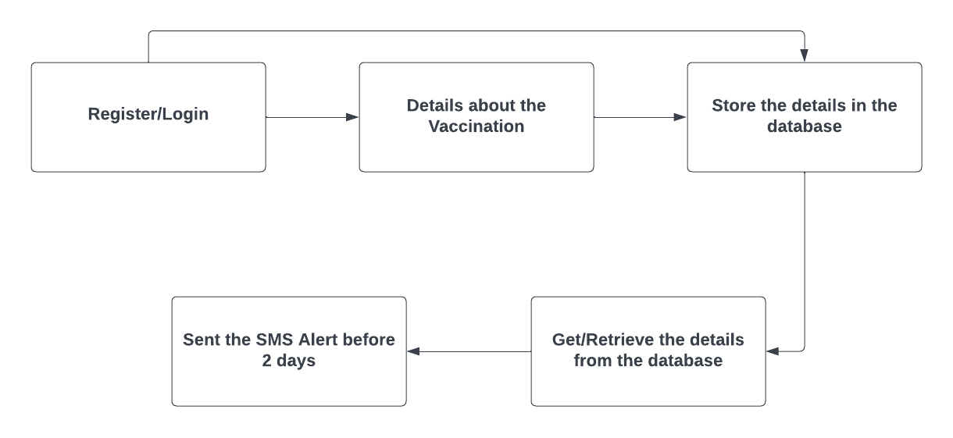

**Figure 6.2: Block Diagram for Vaccination Reminder via SMS.**

**6.3 ARCHITECTURE DIAGRAM**

**Figure 6.3: Architecture Diagram for our proposed system.**

**6.4 COMPONENT DIAGRAM**

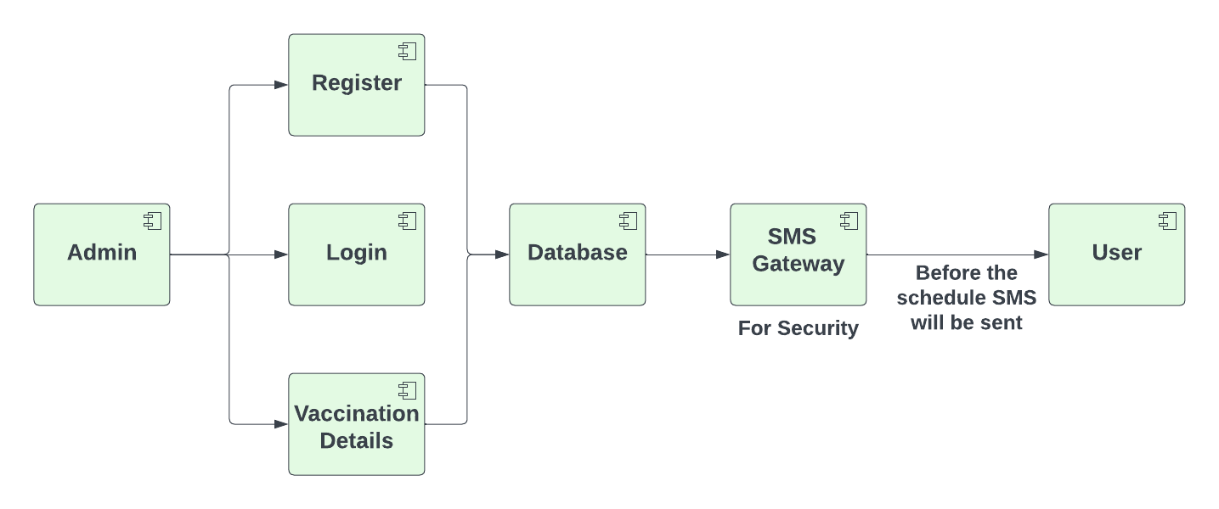

**Figure 6.4: Component Diagram for our proposed system.**

**6.5 DATAFLOW LEVEL 0 DIAGRAM**

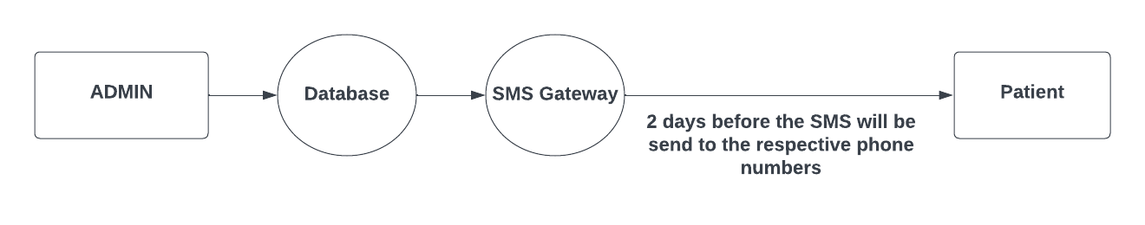

**Figure 6.5: Dataflow level 0 Diagram for our proposed system.**

**6.5.1 DATAFLOW LEVEL 1 DIAGRAM**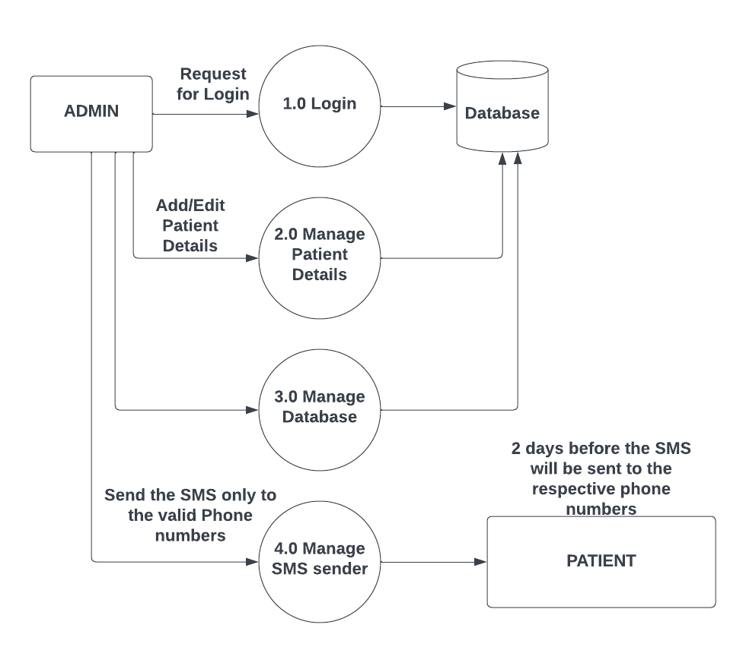

**Figure 6.5.1: Dataflow level 1 Diagram for our proposed system.**

**CHAPTER 7**

**RESULT ANALYSIS**

**7.1 LOGIN PAGE**

To access the system, the admin enters the application ID or mobile number of the users. The system will display the details of that child. After the admin logged in successfully it redirect to the details page and click update in that page to view vaccination details and that will be stored in the database. This makes reminder for parent to take care of their child before they get affected. The below Figure 7.1 shows the user profile page of our web-application. The admin can log with user’s credentials on this user profile page to access information about the immunisation schedule.

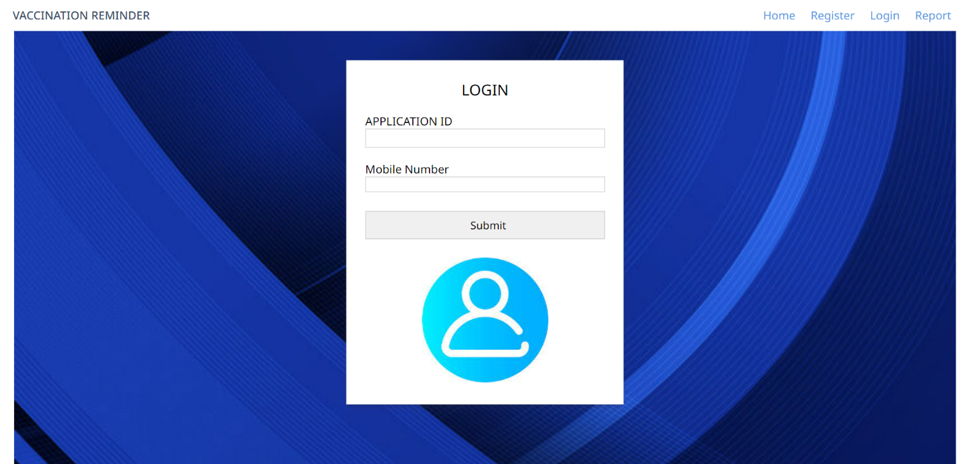

**Figure 7.1: Login page for our vaccination reminder system.**

**7.2 REGISTRATION PAGE**

The details about each individual carer and their infants will be entered in this window. The admin needs to complete the registration process by entering the information requested on this registration page. Information includes name, father name, mother name, gender, parent’s contact information, and email ID. The data gathered in this webpage will be

saved to enable SMS reminders from the database and the text message contains the vaccination schedule and if the child vaccinated then they receive vaccination successful message. The below Figure 7.2 shows the registration page of our web-application.

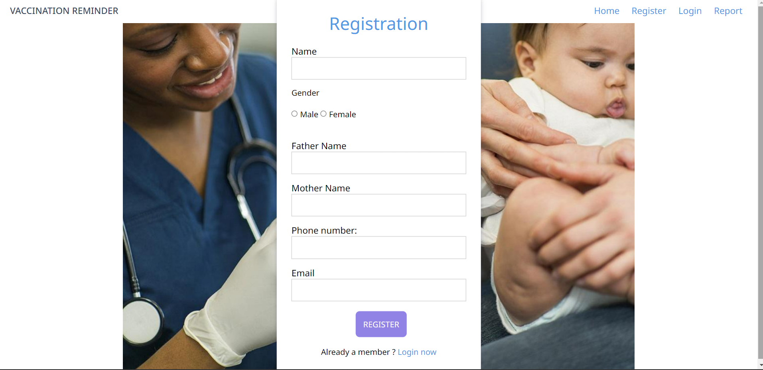

**Figure 7.2: Registration Form for our vaccination reminder system.**

**7.3 VACCINATION SCHEDULING SETUP**

Once the admin logged in to the page using user’s application id or mobile number it automatically redirects to the details page and click update button to view the vaccination page. The admin enters information about the vaccination date and vaccine. This information will be stored on the database and based on the date given in the vaccination details the date will be automatically updated and message will send to the corresponding mobile number. The below Figure 7.3 shows about the vaccination details.

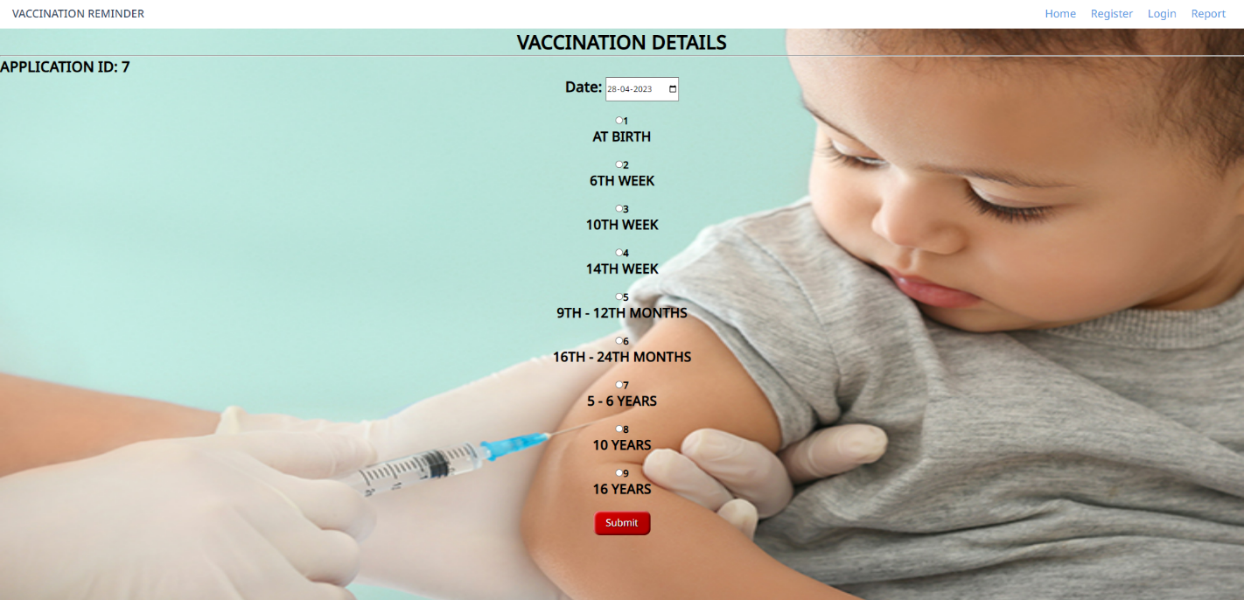

**Figure 7.3: Vaccination Scheduling Setup for our vaccination reminder system.**

**7.4 DATABASE DESIGN**

**7.4.1USERDETAILS**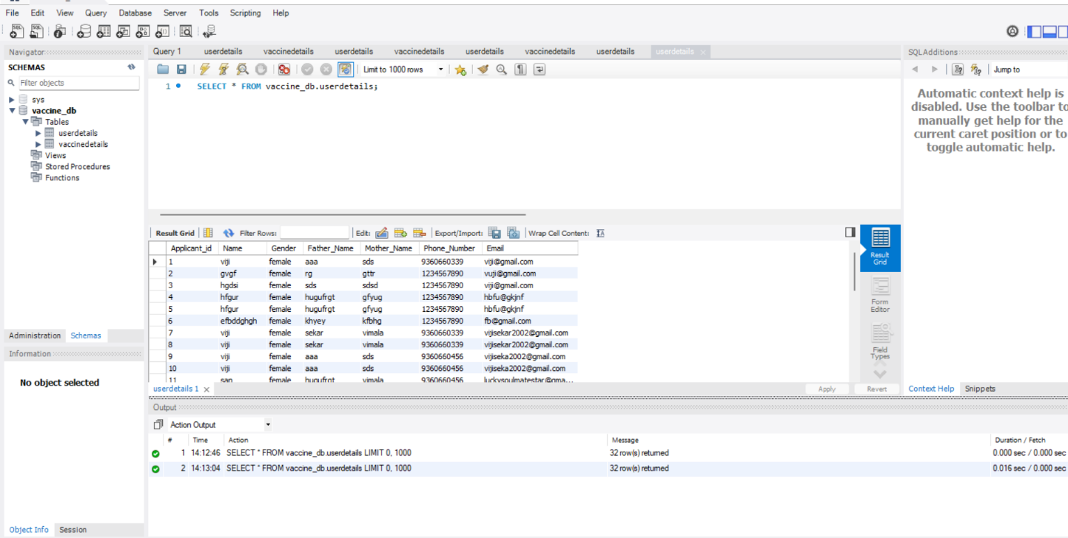

**Figure 7.4.1: UserDetails for our vaccination reminder system.**

**7.4.2 VACCINATION DETAILS**

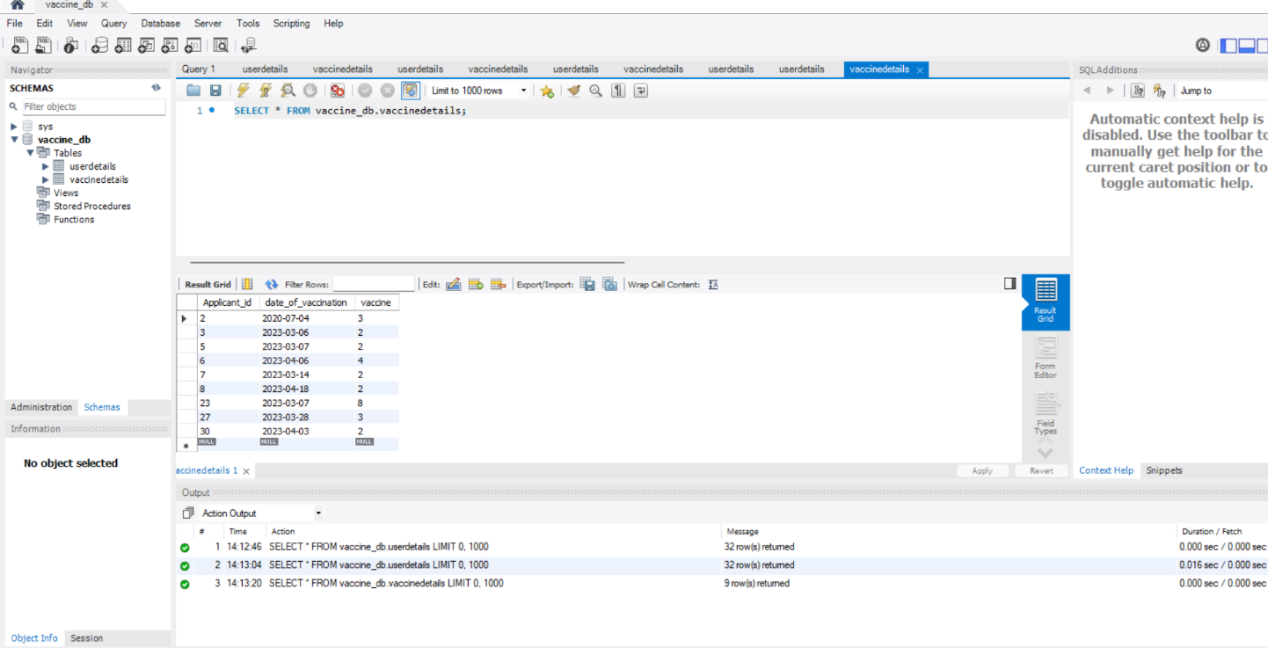

**Figure 7.4.2: Vaccination Details for our vaccination reminder system.**

**7.5** **STATISTICAL REPORT FOR CHILDREN VACCINATION IN INDIA**

**Figure 7.5: Statistical report for the children vaccination.**

Figure 7.5 shows the Statistical report for the children vaccination till 2019. Though the vaccination inception average was up to 80 to 90 percent only. By using the proposed system, we can increase the up to 5 percentage.

**7.6 SMS GATEWAY:TWILIO**

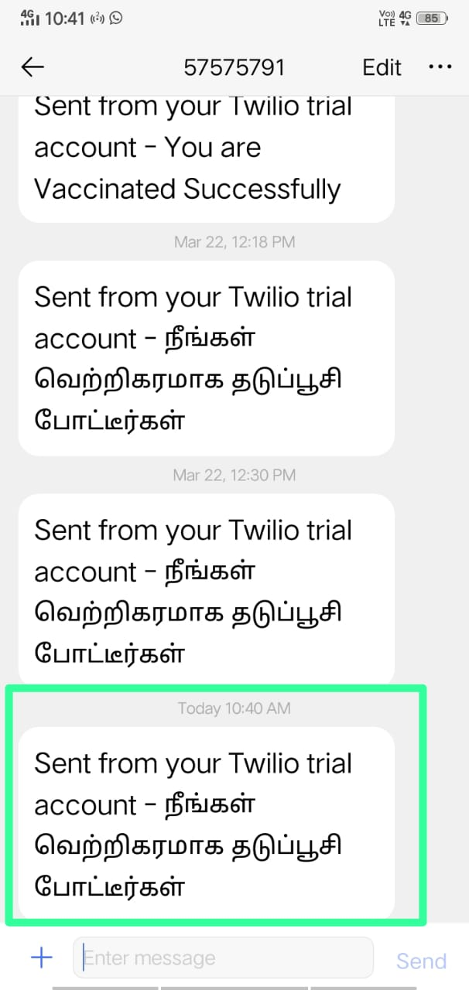

**Figure 7.6 : SMS-A received message on mobile**

**CHAPTER 8**

**8.1 CONCLUSION**

The proposed system is designed to notify parents when it is time to vaccinate their kid. Then, have them SMS the remainder to their parents. Despite their hectic schedules, it has proven to be helpful. Using this web app, the user can rest easy knowing their kid is up to date on vaccinations. Because the timing of the communication is optimal for the recipient. As the date of the last dosage is recorded in the system, the notification to the parents will be sent two days beforehand. Protecting a child's health with timely vaccination is crucial. Thus, the requirements of the users will be fulfilled by this application.

In the future, we may employ this method of delivering notification reminders to help diabetic patients take their prescription on time, since they often need more pharmaceutical drugs than are typically provided by government hospitals. In addition, we may work this into our routine of administering the injections required for the Rabies vaccine on the specified days.

**REFERENCES:-**

[1] Children vaccination reminder via SMS (Asam Hamed Abbas, Yuhanis Yusof) 24 September 2018. Conference Paper · November 2011 DOI: 10.1109/ICRIIS.2011.6125750.

[2] Impat on child vaccination completion rates of short message services(SMS) reminders in developing countries (Robert Davis, American Red Cross, Nairobi, Kenya) 18 Feb 2020. : The Pan African Medical Journal. 2020;35 (Supp 1):12. DOI:10.11604/pamj.supp.2020.35.1.19442.

[3] Development of automated text-message reminder system to improve uptake of child vaccination in (Zeleke Abebaw Mekonnen, Fedlu Nurhussien Hussien, Binyam Tilahun, Kassahun Gelaye and Adane Mamuye) 2019. Online Journal of Public Health Informatics ISSN 1947-2579 http://ojphi.org 11(2):e15,.

[4] Parental remainder and planner for children vaccination (Siti Nazazihah Rahmat, Arshad Jamal, Mohammed Hazim Alkawaz, Monica Sangaran) 21 November 2019. IEEE 9TH International Conference on system engineering and technology (ICSET), 7 October 2019, Shah Alam, Malaysia.

[5] IAP immunize India: SMS text-based vaccination reminder service program- An innovation (Pejaver. Neonatology) 25 OCTOBER 2020. Arch Dis Child 2020;105(Suppl 1):A1–A238.

[6] Seth R, Akinboyo I, Chhabra A, Qaiyum Y, Shet A, Gupte N et al. Mobile phone incentives for childhood immunizations in rural India. Pediatrics. 2018;141:4.

[7] Kazi AM, Ali M, Zubair K, Kalimuddin H, Kazi AN, Iqbal SP et al. Effect of mobile phone text message reminders on routine immunization uptake in Pakistan: randomized controlled trial. JMIR Public Health and Surveillance. 2018;(4)1:e20.

[8] M Hema Kumar, V Mohanraj, Y Suresh, J Senthilkumar, G Nagalalli Trust aware localized routing and class based dynamic block chain encryption scheme for improved security in WSN Journal Of Ambient Intelligence And Humanized Computing ,Springer Heidelberg 2020/4/30 (SCI – Impact factor 1.91)

[9] Mekonnen ZA, Gelaye KA, Were MC, Gashu KD, Tilahun BC. Effect of mobile text message reminders on routine childhood vaccination: a systematic review and meta-analysis. Syst Rev. 2019 Jun 28;8(1):154.

[10] C. Elaine and A. D.-S. Matheson, "Increasing HPV Vaccination Series Completion Rates via Text Message Reminders", Journal of Pediatric Health Care, vol. 28, no. 4, pp. e35-e39, 2014.

[11] G.Mohanraj,V Mohanraj, J Senthilkumar, Y Suresh,” A hybrid deep learning model for predicting and targeting the less immunized area to improve childrens vaccination rate ”, Intelligent Data Analysis 24(6):1385-1402,2020.

[12] M. Annika and C. Y. Hofstetter, "Parental and provider p and concerns regarding text message reminder/recall for early childhood vaccinations", Preventive Medicine, vol. 57, no. 2, pp. 75-80, 2013.

[13] Szilagyi PG, et al. Effect of patient reminder/recall interventions on immunization rates: a review. Jama. 2000;284(14):1820–7.

[14] Almohamed, Asam Hamed Abbas & Yusof, Yuhanis (2011) Children vaccination reminder via SMS alert. In Proceedings of the 2011 International Conference on Research and Innovation in Information Systems (ICRIIS 2011). Institute of Electrical and Electronics Engineers (IEEE), United States of America, pp. 389-393.

[15] Karthikeyan, D. & Mohanraj, V. & Suresh, Y. & Senthilkumar, J.. (2020). “Hybrid Intrusion Detection System Security Enrichment Using Classifier Ensemble”,Journal of Computational and Theoretical Nanoscience.,Vol 17,No.1,PP 434-438 ,2020.